Finance & Billing Platform - Project Documentation

1. Executive Summary
The Finance & Billing Platform is a web-based financial management system developed using ASP.NET Core MVC, ASP.NET Core Web API, Entity Framework Core, SQL Server, JWT Authentication, and Clean Architecture principles. The platform supports controlled user onboarding, role-based access, invoice creation, payment recording, revenue tracking, audit visibility, and dashboard analytics.
The solution is designed as an academic capstone project and as a technical demonstration of enterprise application development practices. It separates presentation, API, domain contracts, business services, data access, and persistence concerns into independent projects. This structure improves maintainability, testability, and scalability while demonstrating core software engineering concepts such as dependency inversion, repository pattern, service layer architecture, validation, authentication, authorization, and unit testing.
The system supports three primary user roles: Admin, Manager, and Client. Admin users control approval and role assignment. Managers handle billing operations such as invoice and payment processing. Clients access their dashboard, invoice information, and payment information. The platform also records key operational actions in audit logs to improve accountability.

2. Project Overview
The Finance & Billing Platform provides a structured environment for managing customers, invoices, payments, and financial summaries. It combines an ASP.NET Core MVC front end with a secured ASP.NET Core Web API back end. The MVC application provides Razor views for browser-based workflows, while the Web API exposes RESTful endpoints for authentication, dashboard summaries, user approval, invoice management, payment management, and audit log retrieval.
The solution follows a layered design:
Layer | Responsibility
MVC Presentation Layer | Renders Razor views, handles form submission, performs client-side interactions, manages browser cookie sessions, and calls the Web API through ApiService.
API Layer | Exposes HTTP endpoints, enforces JWT authentication and role-based authorization, handles request routing, and returns API responses.
Core Layer | Contains entities, DTOs, enums, repository interfaces, and service interfaces. This layer represents the domain model and application contracts.
Infrastructure Layer | Implements repositories, services, EF Core DbContext, entity configurations, JWT generation, password hashing, and dependency injection registration.
Database Layer | Persists users, roles, invoices, payments, approvals, and audit logs in SQL Server through Entity Framework Core.
Test Layer | Uses xUnit and Moq to test service-layer business logic without requiring a live database.

This separation ensures that the domain and business rules are not tightly coupled to the UI or database framework.

3. Business Problem
Organizations that manage customer billing often need a secure and reliable way to track invoices, collect payments, monitor revenue, and control access to sensitive financial records. Manual billing processes can lead to duplicate records, delayed approvals, unclear payment status, weak accountability, and limited reporting visibility.
The business problem addressed by this project is the need for a centralized finance and billing system that can:
- Authenticate users securely.
- Assign permissions based on business roles.
- Approve users before they access protected features.
- Maintain customer billing information.
- Generate and track invoices.
- Record payments against invoices.
- Calculate revenue, collections, and outstanding balances.
- Provide management-level dashboard analytics.
- Keep an audit trail of critical business actions.
The platform reduces administrative overhead, improves billing traceability, and provides a structured financial workflow suitable for small and medium-sized organizations.

4. Objectives
The main objectives of the Finance & Billing Platform are:
- To implement a secure role-based finance application using ASP.NET Core MVC and ASP.NET Core Web API.
- To provide controlled user registration, login, approval, and role assignment.
- To allow managers to create customer invoices and record payments.
- To allow clients to view billing-related information assigned to them.
- To calculate dashboard metrics such as total billed, total collected, outstanding amount, and invoice status counts.
- To persist finance data using Entity Framework Core and SQL Server.
- To use Clean Architecture concepts for separation of concerns and maintainability.
- To implement a repository pattern and service layer architecture.
- To secure API endpoints with JWT bearer authentication and role-based authorization.
- To support audit logging for important user and financial operations.
- To validate user input at the MVC ViewModel and API DTO boundaries.
- To verify core service logic using unit tests.

5. Key Features
The platform includes the following major functional and technical features:
Feature | Description
User Registration and Login | Users can create accounts and authenticate through the system. Registration creates an inactive workflow state that requires admin approval before login access is granted.
JWT Authentication | The Web API issues signed JWT tokens after successful login. Tokens include user identifier, username, and role claims.
Role-Based Authorization | API and MVC actions are protected using Admin, Manager, and Client roles. Authorization controls access to user approval, billing operations, audit logs, and role-specific views.
Customer Management | Approved users with the Client role are available as billing customers for invoice creation.
Invoice Management | Managers can create invoices for clients, set due dates, define total amounts, and track invoice status.
Payment Management | Managers can record payments against invoices and update invoice status based on total collected amount and due date.
Revenue Tracking | The dashboard calculates total billed, total collected, outstanding balance, and invoice counts.
Dashboard Analytics | The dashboard displays financial summary cards, invoice status counts, and recent audit activity.
RESTful APIs | The API exposes endpoints for authentication, users, invoices, payments, dashboard summaries, and audit logs.
Entity Framework Core Integration | EF Core maps domain entities to SQL Server tables and applies entity configurations from the Infrastructure project.
SQL Server Database | SQL Server stores all persistent user, billing, payment, approval, and audit records.
MVC Razor Views | Razor views provide pages for login, registration, dashboard, invoices, payments, users, and audit logs.
AJAX Integration | jQuery AJAX is used for dynamic UI operations such as loading clients, submitting invoices, recording payments, and approving users.
Data Validation | MVC ViewModels use data annotation attributes such as Required, EmailAddress, DataType, and Compare.
Repository Pattern | Repository interfaces in the Core layer abstract data access, while Infrastructure repositories implement EF Core queries.
Service Layer Architecture | Business workflows are implemented in services such as AuthService, UserService, InvoiceService, PaymentService, and DashboardService.
Dependency Injection | Services, repositories, security services, DbContext, and HttpClient integration are registered through ASP.NET Core dependency injection.
Exception Handling | API exceptions are processed by middleware and returned as consistent JSON responses. MVC controllers handle failed API calls with view or JSON error messages.
Unit Testing | xUnit and Moq tests cover authentication, user approval, invoice creation, payment status updates, and service mapping logic.
Secure API Endpoints | Protected endpoints require bearer tokens and use [Authorize] attributes with role restrictions where required.

Role Permission Matrix
The business access model is organized as follows:
Feature | Admin | Manager | Client
Register | Yes | Yes | Yes
Login | Yes | Yes | Yes
Approve Users | Yes | No | No
Assign Roles | Yes | No | No
View Users | Yes | No | No
Create Invoice | No | Yes | No
Edit Invoice | No | Yes | No
Record Payment | No | Yes | No
View Own Invoices | No | No | Yes
View Own Payments | No | No | Yes
View Audit Logs | Yes | Yes | No

Implementation alignment note: the current MVC navigation and Web API controller protect audit log viewing as Admin-only, while the business matrix above lists audit log viewing for Admin and Manager. The current API also permits Admin users on invoice and payment write endpoints, while the MVC interface exposes those operations only to Manager users. If the stricter business matrix is required for final deployment, the affected [Authorize] policies should be aligned across both API and MVC layers.

Role-Based Menu Structure
Role | Available MVC Modules
Admin | Dashboard, Invoices, Payments, Users & Roles, Audit Logs
Manager | Dashboard, Invoices, Payments
Client | Dashboard, Invoices, Payments

6. System Architecture
The system uses a Clean Architecture-inspired solution structure. The Core project contains business contracts and domain models. The Infrastructure project implements these contracts using EF Core, SQL Server, BCrypt, and JWT generation. The API project exposes secured HTTP endpoints. The MVC project consumes those endpoints and presents the user interface.
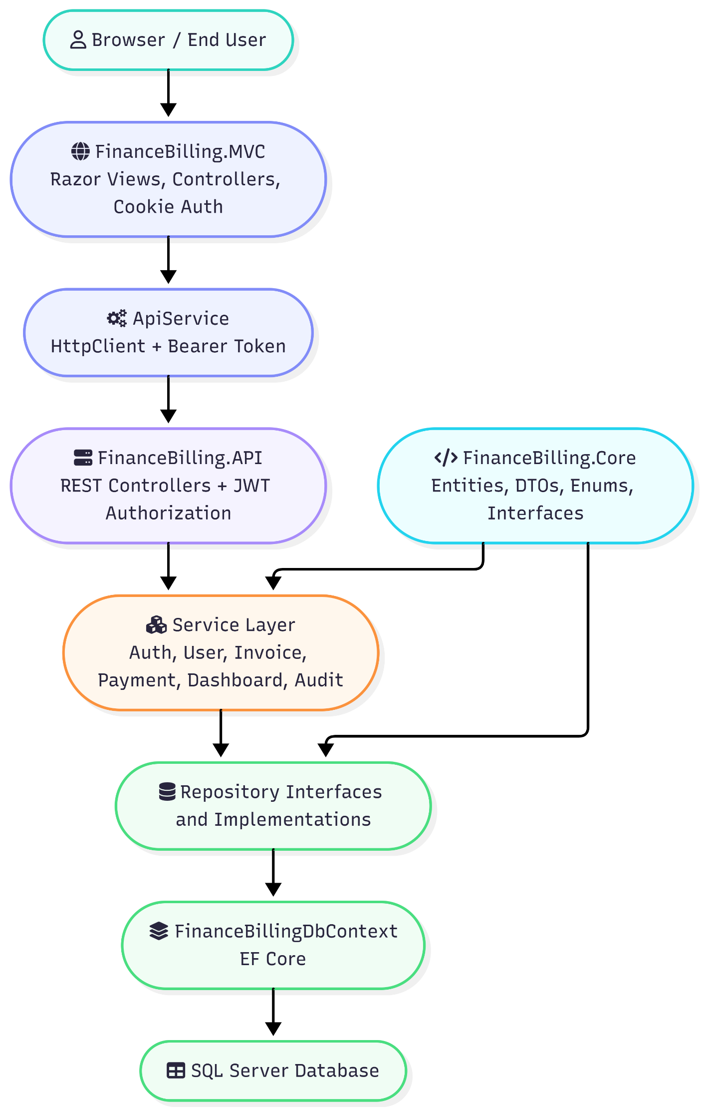

Architecture Explanation
The architecture applies separation of concerns in the following way:
- The MVC layer does not directly access SQL Server. It communicates with the API through ApiService.
- The API layer does not contain persistence logic. It delegates business workflows to services through interfaces.
- The service layer contains application rules such as approval, invoice creation, payment recording, status updates, and audit logging.
- The repository layer contains EF Core data access operations and hides DbContext usage behind interfaces.
- The Core layer remains independent of ASP.NET Core MVC, Web API, EF Core implementation classes, and SQL Server.
- The Infrastructure layer depends on Core and provides concrete implementations.
- Dependency Injection connects abstractions to implementations at runtime.
This design makes the platform easier to test because services can be tested with mocked repositories.

7. Technology Stack
Category | Technology
Programming Language | C#
Runtime and Framework | .NET 10.0
Web UI | ASP.NET Core MVC, Razor Views
API | ASP.NET Core Web API
ORM | Entity Framework Core 10
Database | SQL Server, SQL Server Express connection string in development
Authentication | JWT Bearer Authentication for API, Cookie Authentication for MVC
Authorization | ASP.NET Core role-based authorization
Password Security | BCrypt.Net-Next
API Documentation | NSwag/OpenAPI, Swagger UI, ReDoc
Client-Side Libraries | Bootstrap, Bootstrap Icons, jQuery, DataTables
Testing | xUnit, Moq, Microsoft.NET.Test.Sdk, coverlet.collector
Architecture Patterns | Clean Architecture, Repository Pattern, Service Layer, Dependency Injection

8. Project Structure
The solution is organized into five main projects:
FinanceBillingSolution/
|-- FinanceBilling.API/
| |-- Controllers/
| | |-- AuthController.cs
| | |-- UsersController.cs
| | |-- InvoicesController.cs
| | |-- PaymentsController.cs
| | |-- DashboardController.cs
| | |-- AuditLogsController.cs
| |-- Middleware/
| | |-- ExceptionMiddleware.cs
| |-- Program.cs
| |-- appsettings.json
|
|-- FinanceBilling.Core/
| |-- DTOs/
| |-- Entities/
| |-- Enums/
| |-- Interfaces/
| | |-- Repositories/
| | |-- Services/
|
|-- FinanceBilling.Infrastructure/
| |-- Configurations/
| |-- Data/
| | |-- FinanceBillingDbContext.cs
| |-- Migrations/
| |-- Repositories/
| |-- Security/
| |-- Services/
| |-- DependencyInjection.cs
|
|-- FinanceBilling.MVC/
| |-- Controllers/
| |-- Services/
| | |-- ApiService.cs
| |-- ViewModels/
| |-- Views/
| |-- wwwroot/
| | |-- css/
| | |-- js/
| |-- Program.cs
| |-- appsettings.json
|
|-- Tests/
| |-- AuthServiceTests.cs
| |-- UserServiceTests.cs
| |-- InvoiceServiceTests.cs
| |-- PaymentServiceTests.cs

Layer-Wise Responsibilities
Project | Responsibility
FinanceBilling.Core | Defines domain entities, DTOs, enums, repository interfaces, and service interfaces. It represents the application contract and should remain independent of UI and database implementation details.
FinanceBilling.Infrastructure | Implements repositories and services, configures EF Core mappings, handles password hashing, generates JWT tokens, and registers dependencies.
FinanceBilling.API | Hosts REST endpoints, configures JWT authentication, exposes Swagger/ReDoc documentation, and applies global exception middleware.
FinanceBilling.MVC | Provides the user interface, cookie authentication, Razor views, AJAX workflows, and API consumption through HttpClient.
Tests | Contains service-layer unit tests with mocked dependencies.

9. Database Design
The database is managed through Entity Framework Core using FinanceBillingDbContext. The DbContext exposes the following DbSets:
- Roles
- Users
- UserApprovals
- Invoices
- Payments
- AuditLogs
Entity configurations are applied automatically using modelBuilder.ApplyConfigurationsFromAssembly(...). This keeps database mapping rules separated from entity classes.

Database Tables
Table | Purpose | Important Columns
Roles | Stores application roles. | RoleId, RoleName
Users | Stores registered users and authentication-related information. | UserId, Username, Email, PasswordHash, RoleId, IsApproved, IsActive, CreatedAt, LastLoginAt
UserApprovals | Stores approval history for users. | ApprovalId, UserId, ApprovedByUserId, AssignedRoleId, ApprovedAt, Remarks
Invoices | Stores invoice records created for clients. | InvoiceId, ClientUserId, CreatedByManagerId, InvoiceDate, DueDate, TotalAmount, Status, CreatedAt
Payments | Stores payments recorded against invoices. | PaymentId, InvoiceId, AmountPaid, PaymentDate, PaymentMethod
AuditLogs | Stores business activity history. | AuditLogId, UserId, Action, EntityName, EntityId, Details, ChangedAt

Database Constraints and Configuration
Entity | Configuration
Role | Primary key on RoleId; RoleName is required, max length 50, and unique. Seeded roles are Admin, Manager, and Client.
User | Primary key on UserId; Username is required, max length 100, and unique; Email is required, max length 150, and unique; PasswordHash is required with max length 500.
UserApproval | Primary key on ApprovalId; Remarks max length 500; relationships to approved user, approving user, and assigned role use restricted delete behavior.
Invoice | Primary key on InvoiceId; TotalAmount uses decimal precision (18,2); relationships to client and manager use restricted delete behavior.
Payment | Primary key on PaymentId; AmountPaid uses decimal precision (18,2); PaymentMethod is required with max length 50.
AuditLog | Primary key on AuditLogId; Action and EntityName are required with max length 100; relationship to user uses restricted delete behavior.

The system seeds a default Admin user and the three default roles. This ensures that the application can be administered immediately after the database is created.

10. Entity Relationships
The platform contains the following primary relationships:
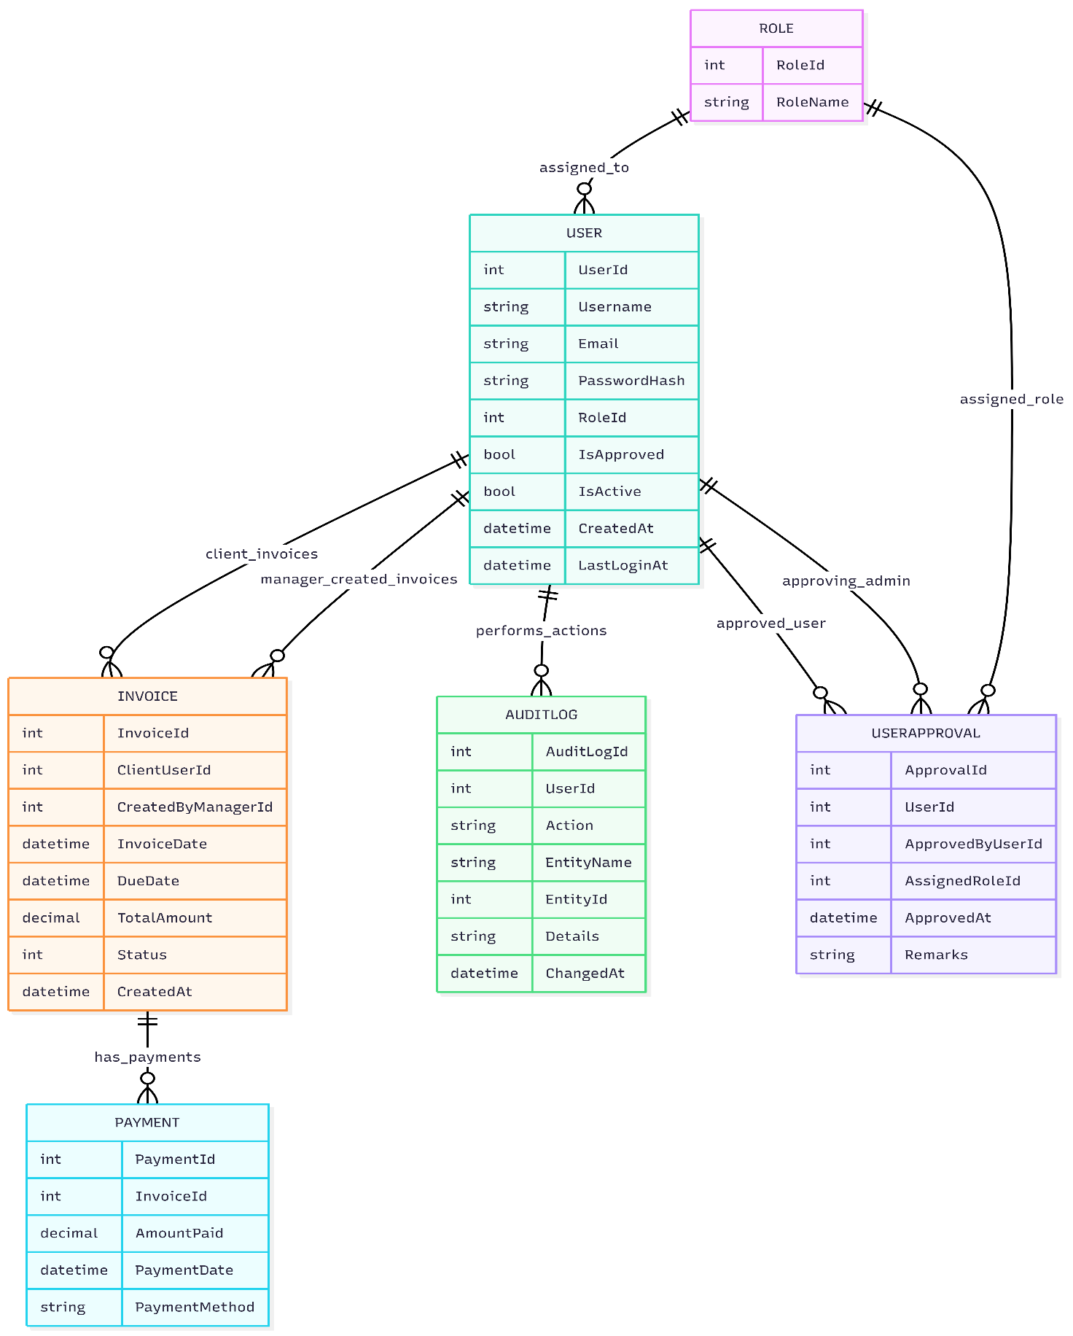

Relationship Explanations
- One Role can be assigned to many Users.
- One User with the Client role can have many client invoices through ClientInvoices.
- One User with the Manager role can create many invoices through ManagedInvoices.
- One Invoice can have many Payments.
- One User can generate many AuditLogs.
- One UserApproval links the approved user, the approving admin, and the assigned role.
- Restricted delete behavior protects historical financial records from accidental cascade deletion.

11. Core Components

Domain Entities
Entity | Description
User | Represents an application user with credentials, approval status, active status, role assignment, login timestamp, invoices, and audit logs.
Role | Represents a security role such as Admin, Manager, or Client.
UserApproval | Represents the approval event where an admin approves a registered user and assigns a role.
Invoice | Represents a billing record for a client. It stores invoice dates, due date, amount, status, client reference, manager reference, and related payments.
Payment | Represents a payment made against an invoice. It records amount, date, method, and invoice reference.
AuditLog | Represents an auditable action performed by a user, including the action name, affected entity, details, and timestamp.

Service Components
Service | Responsibility
AuthService | Handles registration, duplicate username/email checks, password hashing, approval validation, password verification, JWT creation, and last-login updates.
UserService | Retrieves pending users, approves users, assigns roles, retrieves approved clients, and records user approval audit logs.
InvoiceService | Creates invoices, sets invoice status to Pending, maps invoices to DTOs, retrieves all invoices, retrieves client invoices, and records invoice audit logs.
PaymentService | Records payments, retrieves invoice payments, retrieves all payments, recalculates invoice payment status, and records payment audit logs.
DashboardService | Aggregates financial KPIs such as billed amount, collected amount, outstanding balance, invoice counts, and recent activity.
AuditLogService | Retrieves audit logs and maps them to DTOs for display.

Repository Components
Repository | Responsibility
UserRepository | Retrieves users by ID, username, email, pending approval status, and approved Client role; adds and updates users.
InvoiceRepository | Retrieves invoices by ID, all invoices with client information, invoices by client, and supports insert/update operations.
PaymentRepository | Retrieves payments by ID, invoice ID, and all payments; adds payment records.
AuditLogRepository | Adds audit entries and retrieves audit history ordered by most recent activity.

Security Components
Component | Responsibility
PasswordService | Hashes and verifies passwords using BCrypt.
JwtTokenService | Generates signed JWT tokens with user ID, username, role claims, issuer, audience, and expiration.
ExceptionMiddleware | Catches API exceptions and returns a JSON error response.
ApiService | Sends authenticated and unauthenticated HTTP requests from MVC to API endpoints.

12. Authentication & Security
The platform applies multiple security mechanisms across the API and MVC applications.

Registration and Approval Flow
- A user registers through the MVC registration page or API registration endpoint.
- The system checks whether the username already exists.
- The system checks whether the email already exists.
- The password is hashed using BCrypt.
- The user is created with IsApproved = false and IsActive = true.
- An Admin reviews pending users.
- The Admin approves the user and assigns a role.
- After approval, the user can log in and access role-specific features.

Login and JWT Generation
During login, AuthService retrieves the user by username, verifies approval status, validates the password using BCrypt, generates a JWT token, updates LastLoginAt, and returns a LoginResponseDto containing:
- Token
- Username
- Role
The JWT contains the following claims:
- ClaimTypes.NameIdentifier: user ID.
- ClaimTypes.Name: username.
- ClaimTypes.Role: assigned role.
The token is signed using HMAC SHA-256 and expires after 2 hours.

API JWT Validation
The API configures JWT bearer authentication with:
- Issuer validation.
- Audience validation.
- Lifetime validation.
- Issuer signing key validation.
- Symmetric security key from configuration.
Protected API endpoints require the Authorization: Bearer <token> header.

MVC Session Security
The MVC application uses cookie authentication for browser sessions. After successful login, the MVC controller stores the username, role, and JWT token as claims in a cookie-authenticated principal. The ApiService reads the JWT claim and sends it as a bearer token when calling protected API endpoints.
Cookie settings include:
- Login path: /Account/Login
- Access denied path: /Account/AccessDenied
- Expiration time: 2 hours
- Sliding expiration: enabled

Role-Based Authorization
Role-based authorization is implemented using [Authorize] and [Authorize(Roles = "...")] attributes.
Examples:
- Admin-only user approval: UsersController.GetPendingUsers, UsersController.Approve.
- Manager/Admin invoice creation at API level: InvoicesController.Create.
- Manager/Admin payment recording at API level: PaymentsController.AddPayment.
- Authenticated dashboard summary: DashboardController.GetSummary.
- Admin-only audit logs in current implementation: AuditLogsController.GetAll.

Additional Security Practices
- Passwords are never stored in plain text.
- API endpoints use HTTPS redirection.
- MVC uses anti-forgery tokens on form and AJAX POST operations.
- Admin approval prevents unauthorized self-service access to protected business features.
- Role claims are embedded in JWT tokens and validated by the API.
- SQL Server access is mediated through EF Core instead of raw SQL string construction.
Production recommendation: JWT secret keys and database connection strings should be moved from appsettings.json into environment variables, user secrets, Azure Key Vault, or another secure secret store.

13. API Endpoints
The Web API exposes RESTful endpoints under the /api route prefix. ASP.NET Core routing is case-insensitive, so routes such as /api/Auth/login and /api/auth/login resolve equivalently.
Method | Endpoint | Authorization | Request DTO | Description
POST | /api/auth/register | Public | RegisterRequestDto | Registers a new user account and places it in pending approval status.
POST | /api/auth/login | Public | LoginRequestDto | Authenticates an approved user and returns a JWT token with role details.
GET | /api/users/pending | Admin | None | Returns users awaiting approval.
POST | /api/users/approve | Admin | ApproveUserDto | Approves a user and assigns a role.
GET | /api/users/clients | Admin, Manager | None | Returns approved Client users for invoice assignment.
POST | /api/invoices | Manager, Admin at API level | CreateInvoiceDto | Creates a new invoice for a client and records an audit log.
GET | /api/invoices | Authenticated | None | Returns invoices mapped to InvoiceDto.
POST | /api/payments | Manager, Admin at API level | CreatePaymentDto | Records payment against an invoice, updates invoice status, and records an audit log.
GET | /api/payments | Authenticated | None | Returns payment records mapped to PaymentDto.
GET | /api/dashboard/summary | Authenticated | None | Returns dashboard KPIs and recent activity.
GET | /api/auditlogs | Admin in current implementation | None | Returns audit log records ordered by most recent activity.

API DTO Descriptions
DTO | Fields | Purpose
RegisterRequestDto | Username, Email, Password, ConfirmPassword | Captures registration data.
LoginRequestDto | Username, Password | Captures login credentials.
LoginResponseDto | Token, Username, Role | Returns authentication result after login.
ApproveUserDto | UserId, RoleId, Remarks | Captures user approval and role assignment details.
CreateInvoiceDto | ClientUserId, DueDate, TotalAmount | Captures invoice creation data.
InvoiceDto | InvoiceId, ClientUserId, ClientName, TotalAmount, Status, InvoiceDate, DueDate | Returns invoice data to API consumers.
CreatePaymentDto | InvoiceId, AmountPaid, PaymentMethod | Captures payment recording data.
PaymentDto | PaymentId, InvoiceId, AmountPaid, PaymentDate | Returns payment data to API consumers.
DashboardSummaryDto | totals, invoice counts, recent activities | Returns dashboard analytics.
AuditLogDto | user, action, entity, details, timestamp | Returns audit trail data.

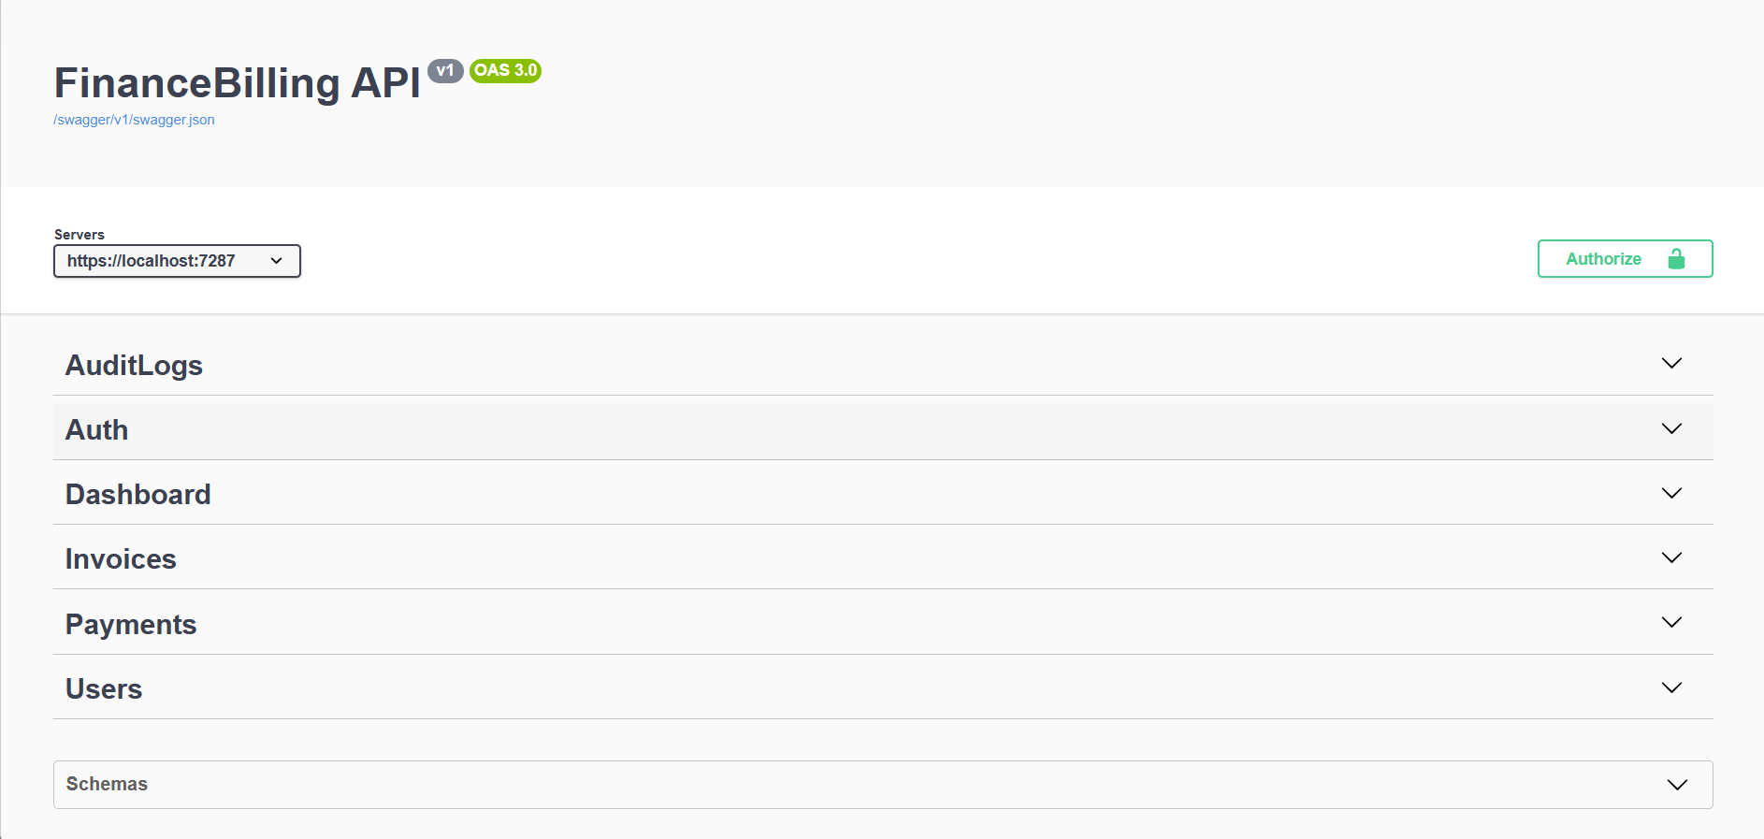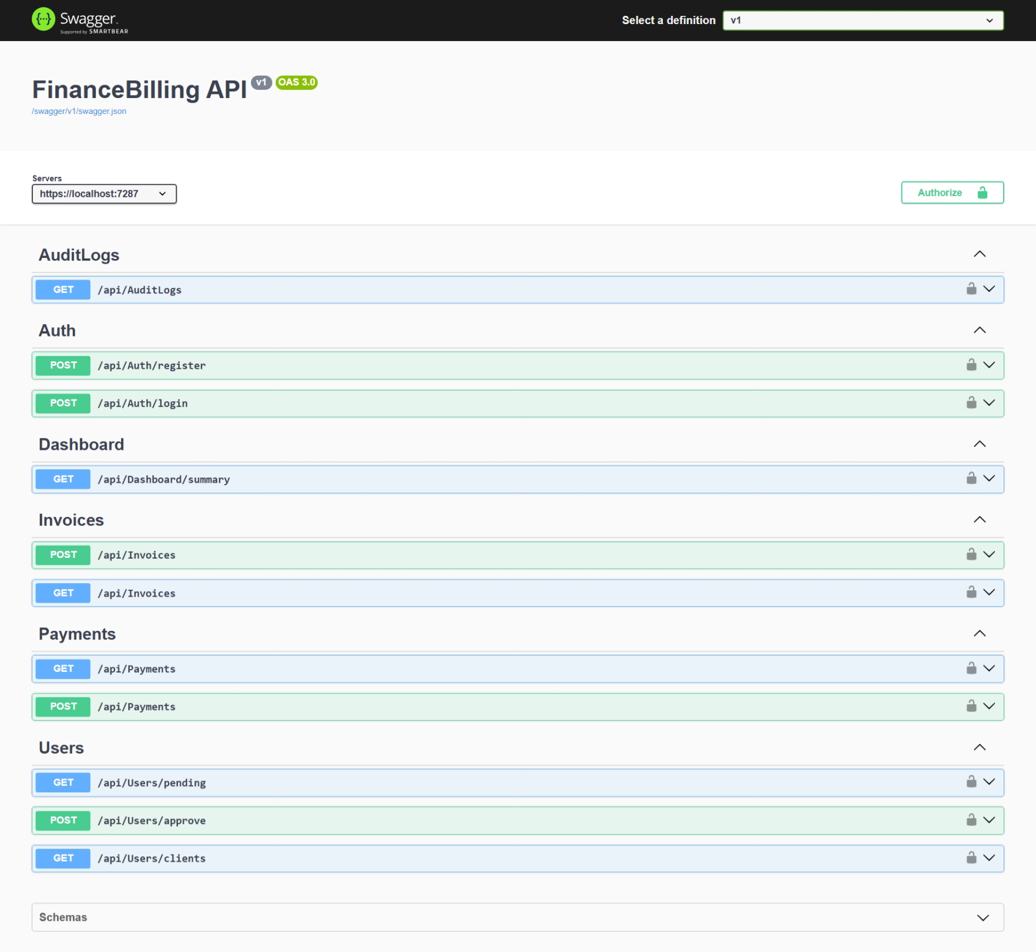14. Business Rules
The system applies the following business rules:

User and Role Rules
- Username must be unique.
- Email address must be unique.
- Passwords must be hashed before storage.
- New registrations are not approved automatically.
- Only approved users can log in.
- Admin users can approve pending users.
- Admin users assign roles during approval.
- System roles are Admin, Manager, and Client.
- Users must have a valid role before accessing role-specific modules.

Invoice Rules
- Invoices are created for Client users.
- Invoice creation is performed by a Manager in the MVC application.
- Each invoice stores the manager who created it.
- New invoices start with Pending status.
- Each invoice has an invoice date, due date, total amount, status, and created timestamp.
- Invoice total amount uses decimal precision for financial accuracy.
- Invoice creation generates an audit log entry.

Payment Rules
- Payments must be associated with an invoice.
- Each payment stores invoice ID, amount paid, payment date, and payment method.
- Payment recording generates an audit log entry.
- After recording a payment, the invoice status is recalculated.
- If total paid is greater than or equal to invoice total amount, the invoice becomes Paid.
- If the invoice is not fully paid and the due date has passed, the invoice becomes Overdue.
- If the invoice is not fully paid and the due date has not passed, the invoice remains Pending.
- The PartiallyPaid status exists in the enum and can be used for future enhancement if partial-payment status should be represented separately.

Dashboard Rules
- Total billed is calculated as the sum of invoice total amounts.
- Total collected is calculated as the sum of payment amounts.
- Outstanding amount is calculated as total billed minus total collected.
- Invoice counts are grouped by status.
- Recent activities are retrieved from audit logs and limited to the most recent entries.

Audit Rules
- User approval is audited.
- Invoice creation is audited.
- Payment recording is audited.
- Audit logs store the acting user, action, entity name, entity ID, details, and timestamp.
- Audit records are ordered by most recent activity during retrieval.

15. MVC Application Features
The MVC application provides a browser-based user interface for the system.

Account Module
- Registration page for creating a new account.
- Login page for authenticated access.
- Logout action for ending the session.
- Model validation using data annotation attributes.
- Cookie-based browser session after successful login.
- JWT token stored as a claim and forwarded to the API.

Dashboard Module
- Displays total billed amount.
- Displays total collected amount.
- Displays outstanding amount.
- Displays total invoice count.
- Displays paid, pending, and overdue invoice counts.
- Displays recent audit activity.
- Refreshes dashboard periodically.

Invoice Module
- Displays invoice list in a table.
- Uses DataTables for enhanced tabular interaction.
- Manager users can open a modal to create an invoice.
- AJAX loads approved clients for invoice creation.
- AJAX submits invoice creation requests.
- Invoice rows display amount, due date, and status.

Payment Module
- Displays payment list in a table.
- Manager users can open a modal to record a payment.
- AJAX loads invoices for payment selection.
- AJAX submits payment records.
- Payment method options include UPI, Card, Bank Transfer, and Cash.

Users & Roles Module
- Admin users can view pending users.
- Admin users can assign Manager or Client role.
- Admin users can approve users through AJAX.
- Approval action updates user status and records an audit log.

Audit Logs Module
- Admin users can access the audit log module in the current MVC navigation.
- Audit logs are retrieved from the API using the stored JWT token.
- Audit records support traceability for important business operations.

UI and Client-Side Integration
- Bootstrap provides responsive layout and styling.
- Bootstrap Icons are used in navigation.
- jQuery handles AJAX interactions.
- DataTables improves table display.
- Anti-forgery tokens are included in MVC forms and AJAX requests.

16. Database Features
The database design supports both operational data and system governance.

EF Core DbContext
FinanceBillingDbContext manages entity sets and applies entity mappings from the Infrastructure assembly. It acts as the bridge between domain entities and SQL Server tables.

Entity Configuration Classes
The system uses separate EF Core configuration classes:
- RoleConfiguration
- UserConfiguration
- UserApprovalConfiguration
- InvoiceConfiguration
- PaymentConfiguration
- AuditLogConfiguration
This design keeps persistence rules separate from domain entities and improves readability.

Seed Data
The database seeds:
- Admin role.
- Manager role.
- Client role.
- Default Admin user.
Seed data ensures that administrative access is available after database creation.

Migrations
EF Core migrations are included in the Infrastructure project. Migrations provide version-controlled schema evolution for creating and updating the SQL Server database.

Financial Precision
Invoice and payment amounts are configured with decimal precision (18,2). This is important for finance applications because floating-point types can introduce rounding errors.

Referential Integrity
Foreign key relationships ensure that:
- Users must reference valid roles when approved.
- Invoices reference valid client and manager users.
- Payments reference valid invoices.
- Audit logs reference valid users.
- Approval records reference approved users, approving admins, and assigned roles.
Restricted delete behavior prevents accidental deletion of users with historical financial and audit records.

17. Validation Rules
Validation is implemented at multiple levels.

MVC ViewModel Validation
ViewModel | Validation
RegisterViewModel | Username required; Email required and must be a valid email address; Password required; ConfirmPassword required and must match Password.
LoginViewModel | Username required; Password required.
CreateInvoiceViewModel | ClientUserId required; DueDate required; TotalAmount required.
CreatePaymentViewModel | InvoiceId required; AmountPaid required; PaymentMethod required.

Service-Level Validation
Service | Validation
AuthService.RegisterAsync | Rejects duplicate username and duplicate email.
AuthService.LoginAsync | Rejects missing user, unapproved account, and invalid password.
UserService.ApproveUserAsync | Rejects approval when the target user does not exist.
PaymentService.AddPaymentAsync | Rejects payment workflow when the invoice cannot be found.

Database-Level Validation
Rule | Implementation
Unique usernames | Unique index on Username.
Unique emails | Unique index on Email.
Required role name | Required property in RoleConfiguration.
Required username, email, and password hash | Required properties in UserConfiguration.
Required payment method | Required property in PaymentConfiguration.
Required audit action and entity name | Required properties in AuditLogConfiguration.

18. Exception Handling
The API includes a custom ExceptionMiddleware component. This middleware wraps the request pipeline and catches unhandled exceptions thrown by controllers or services.
When an exception occurs, the middleware returns a JSON response:
{
"success": false,
"message": "Error message"
}
The current middleware returns HTTP 400 Bad Request for caught exceptions. This provides a consistent response format for service-layer validation errors such as duplicate usernames, duplicate emails, pending approval, missing users, or missing invoices.
MVC controllers also handle unsuccessful API responses:
- Account registration returns a validation error if registration fails.
- Login returns an invalid credentials message if authentication fails.
- Invoice creation returns a JSON failure message if the API call fails.
- Payment creation returns a JSON failure message if the API call fails.
- User approval returns a JSON failure message if approval fails.
- List pages return empty models when API retrieval fails.
Recommended production improvements include:
- Creating custom exception types such as NotFoundException, ValidationException, and UnauthorizedBusinessActionException.
- Mapping exceptions to more specific status codes such as 400, 401, 403, 404, and 409.
- Adding structured logging with correlation IDs.
- Returning RFC 7807 Problem Details responses.
- Preventing sensitive exception details from being exposed in production.

19. Testing Strategy
The project includes a dedicated Tests project using xUnit and Moq. The tests focus on service-layer behavior because the service layer contains the core business rules.

Existing Unit Test Areas
Test File | Coverage
AuthServiceTests.cs | Registration duplicate username, duplicate email, valid registration, user not found during login, pending approval, wrong password, valid login, token response, and last-login update.
UserServiceTests.cs | Pending user retrieval, empty pending list, user not found during approval, approval status update, role assignment, audit log creation, approved client retrieval, and empty client list.
InvoiceServiceTests.cs | Invoice creation with Pending status, invoice audit log creation, invoice DTO mapping, empty invoice list, client invoice retrieval, and empty client invoice list.
PaymentServiceTests.cs | Missing invoice, fully paid status, partial pending status, overdue status, payment audit log creation, payment DTO mapping, and invoice payment retrieval.

Testing Approach
The tests use mocked repository interfaces instead of a real database. This approach has the following advantages:
- Tests run quickly.
- Tests do not require SQL Server setup.
- Business logic can be verified independently from EF Core.
- Edge cases can be simulated with predictable mock data.
- Service dependencies can be verified using Moq.

WebPage:
Admin:
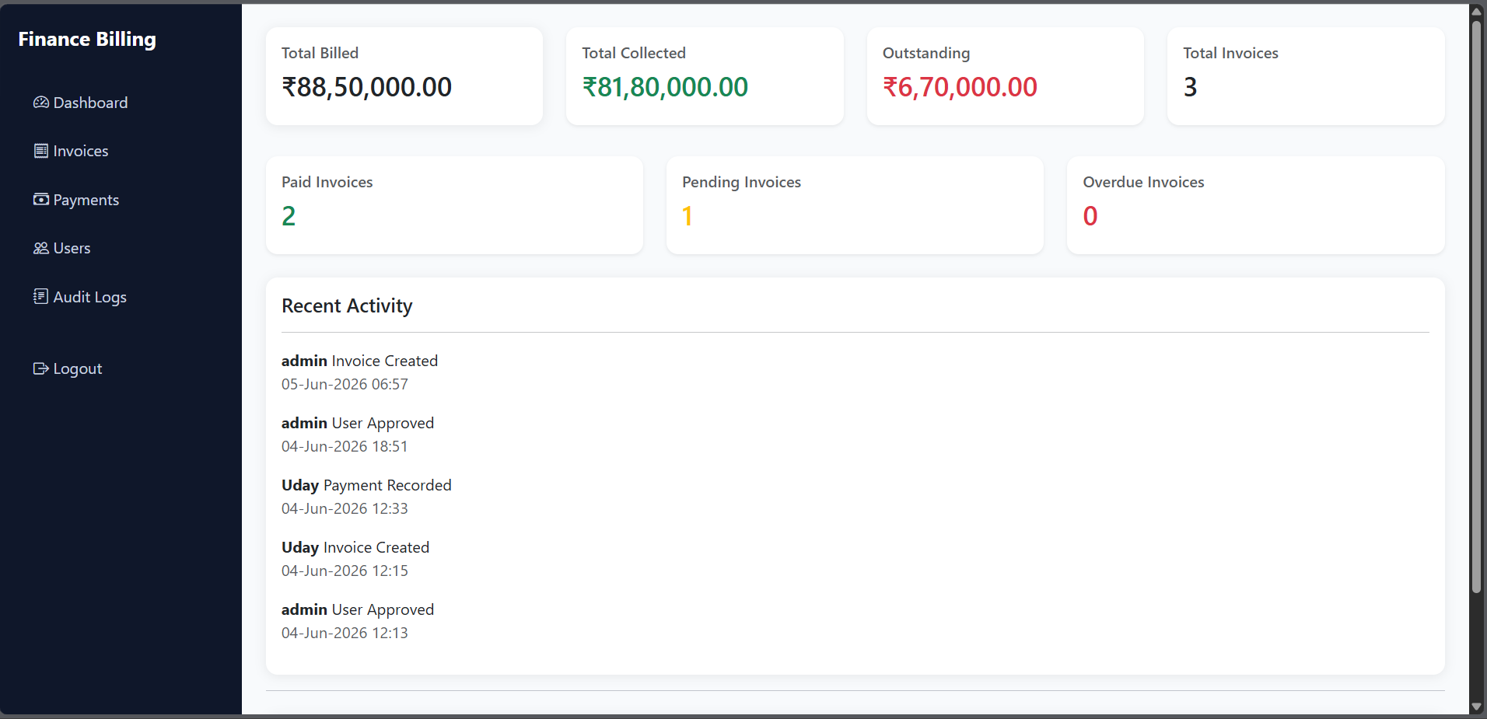
Manager:
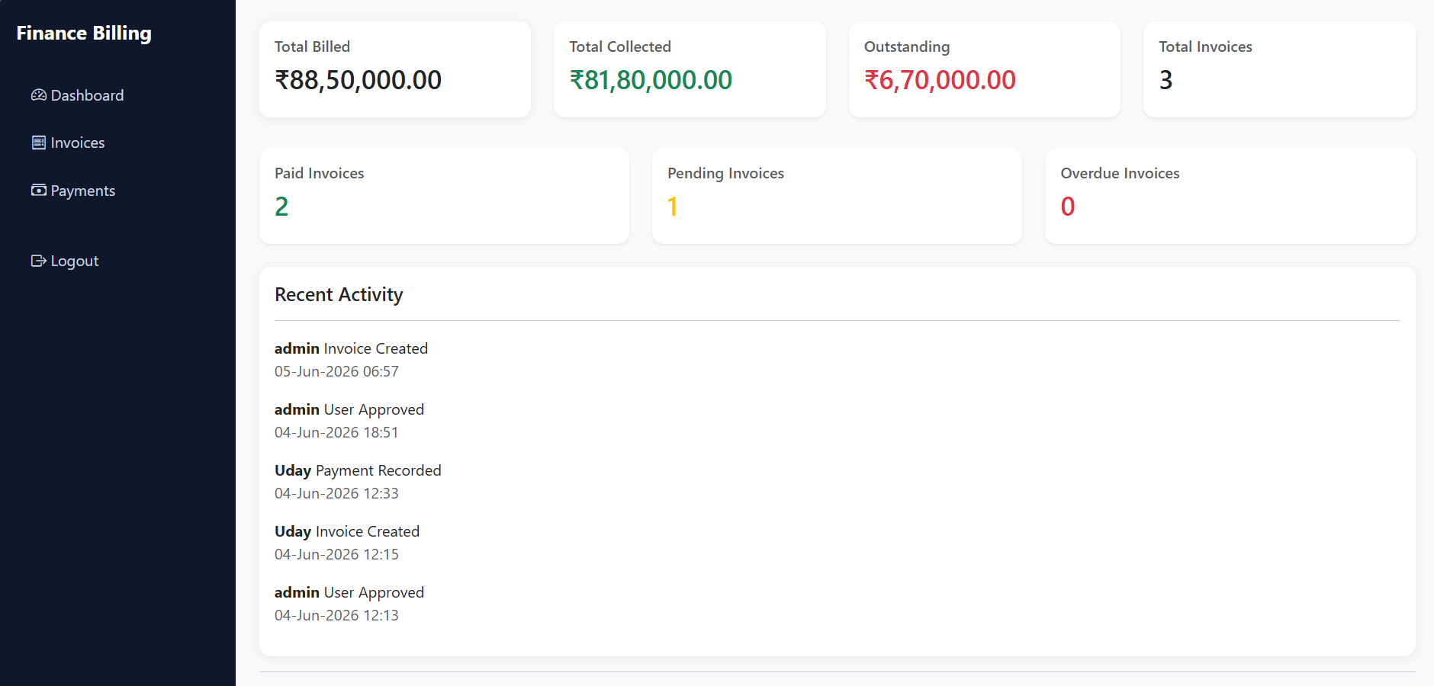

Test Execution
Tests can be executed with:
dotnet test

20. Future Enhancements
The platform can be extended with the following enhancements:
- Add client-scoped API endpoints so Client users can retrieve only their own invoices and payments.
- Implement invoice editing and cancellation workflows for Manager users.
- Add explicit PartiallyPaid invoice status handling.
- Add overpayment prevention and outstanding-balance validation.
- Implement full user listing and advanced role management for Admin users.
- Align Manager audit-log access with the business role matrix if required.
- Add chart-based dashboard analytics using a charting library.
- Add PDF invoice generation and downloadable payment receipts.
- Add email notifications for account approval, invoice creation, overdue invoices, and payment confirmation.
- Add pagination, sorting, and filtering to API endpoints.
- Add soft delete and archival policies for financial records.
- Add refresh tokens and token revocation support.
- Move secrets to a secure configuration provider.
- Add structured logging and centralized monitoring.
- Add integration tests and end-to-end UI tests.
- Add multi-tenant organization support for larger business use cases.
- Add export options for Excel, CSV, and PDF reports.
- Add account lockout, password reset, and stronger password policies.

21. Conclusion
The Finance & Billing Platform demonstrates a complete software engineering solution for secure financial workflow management. It combines ASP.NET Core MVC for user interaction, ASP.NET Core Web API for RESTful service exposure, Entity Framework Core for database persistence, SQL Server for reliable storage, JWT authentication for API security, and Clean Architecture practices for maintainable code organization.
The project addresses real business needs such as controlled user onboarding, customer billing, invoice tracking, payment management, revenue analysis, and auditability. Its layered architecture, repository abstraction, service-oriented business logic, dependency injection, validation, exception handling, and unit testing make it suitable for academic capstone evaluation and technical interview discussion.
Overall, the system provides a strong foundation for a production-ready finance and billing application while leaving clear opportunities for future improvements such as client-scoped access control, advanced reporting, invoice editing, stronger security policies, and deeper integration testing.

